Assignment 1: Programming in Python CST 362

Name: **Alby Thekkedan Roll No 8 Class CS6B**

KTU-ID: **MDL20CS129**

Date of submission: 27-Feb-2023

**Learning outcome: Python basics, operators, modules/packages, control statements**

1. Python is developed by **Guido van Rossum**
2. How Python got its name - **The name, Python comes from an old BBC television comedy sketch series called Monty Python's Flying Circus**
3. Write the output of the statement 2**3**2. **Output - 512**
4. What is the difference between / and // operators. Write one example

**‘ / ’ is Normal division the output will be a real value or floating value. eg: 15/4=3.75**

**‘ // ’ is Integer division or Floor division divides and returns integer value eg: 15//4=3**

1. How the expression 2+3*2**2/3 is evaluated show the order of evaluation and final output

**Ans : 6** 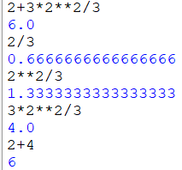

1. 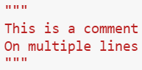How single line and multiline comments are added in Python script

**To make single-line comments in Python, add # to the beginning of each line. #a=7**

**To make multi-line comments in Python, Use docstrings**

1. Write the logical operators

They are **and, or, not**

The **and**operator checks whether **two conditions are both True simultaneously.** It returns True if both conditions are True. And it returns False if either the condition is False.

The **or** operator returns True when **either or both individual conditions are True.** The or operator returns**False**only when **both conditions are False**.

The **not**operator **If the condition is True, the not operator returns False and vice versa.**

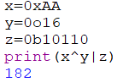

1. x=0xAA, y=0o16, z=0b10110 , find x^y|z

**x is (170)10, y is (14)10, z is (22)10**

**Ans 182**

1. What are bit wise operators

|  |  |  |  |
| --- | --- | --- | --- |
| **OPERATOR** | **NAME** | **DESCRIPTION** | **SYNTAX** |
| & | Bitwise AND | Result bit 1, if both operand bits are 1; otherwise results bit 0. | x & y |
| | | Bitwise OR | Result bit 1, if any of the operand bit is 1; otherwise results bit 0. | x | y |
| ~ | Bitwise NOT | Inverts individual bits | ~x |
| ^ | Bitwise XOR | Results bit 1, if any of the operand bit is 1 but not both, otherwise results bit 0. | x ^ y |
| >> | Bitwise right shift | The left operand’s value is moved toward right by the number of bits specified by the right operand. | x>> |
| << | Bitwise left shift | The left operand’s value is moved toward left by the number of bits specified by the right operand. | x<< |

1. a. How to get the last bit of a number. Write the bitwise operation, e/g: x=2 o/p:0, x=3 o/p:1

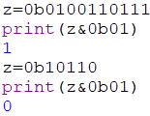b. x=12, what is the output of x<<2 justify your answer

 **BITWISE AND operation with binary 01**

**12 is 1100, left shift by 2 position on left most bit**

**gives 110000, which is (48)10**

1. What are Boolean data types

**The Boolean value can be of two types only i.e. either True or False**.**It is used to represent the truth values of the expressions. For example, 1==1 is True whereas 2<1 is False.**

**Basic Scripting**

1. 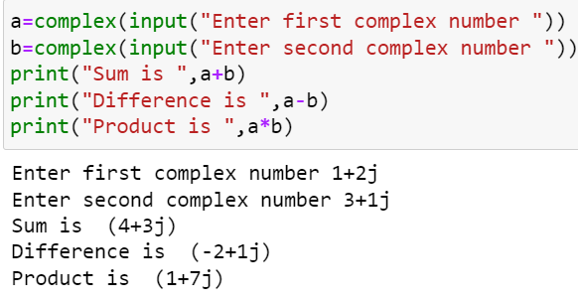Write a Python script which will read two complex numbers and find their sum, difference and product.

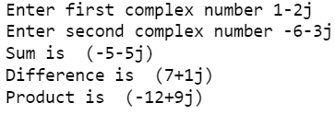



1. Read your phone number and print the last two digit in binary, octal and hex.

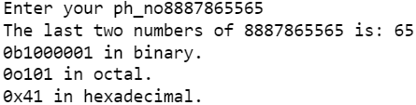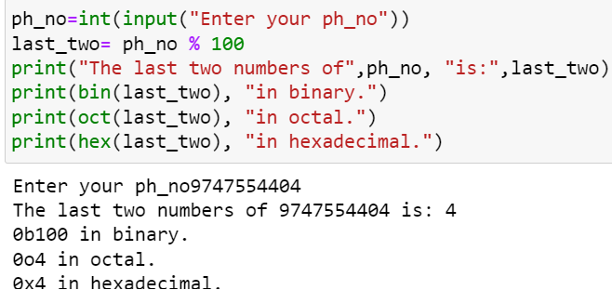

1. Read a hexa decimal number and print the dec, bin and octal equivalent.

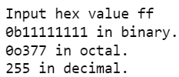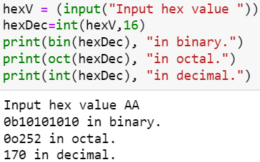

1. Given the center (xc,yc) and a point on the circle(x1,y1). Find the area

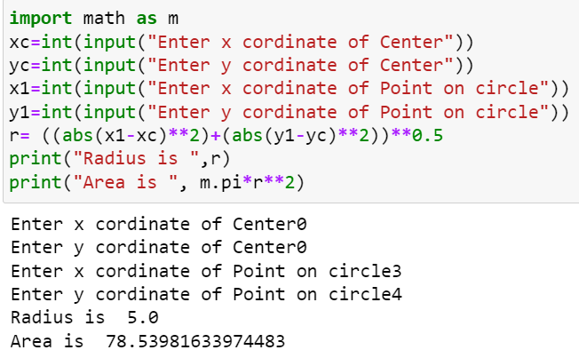

1. Write a Python program to read time in seconds and Print in HH:MM:SS format. i/p in seconds :1000 o/p:00:16:40

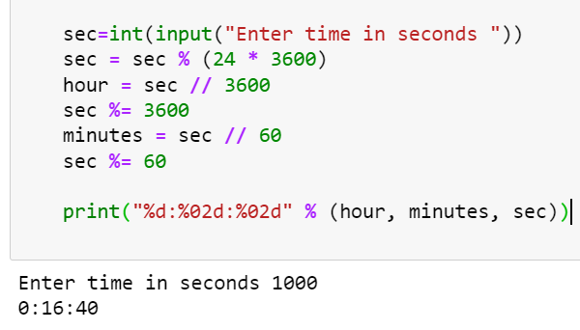

**Use built in functions**

1. Read a number and Print the corresponding binary, oct, hex

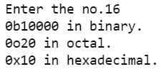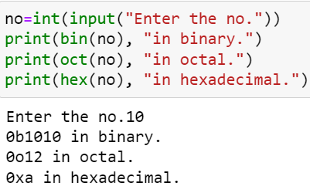

1. 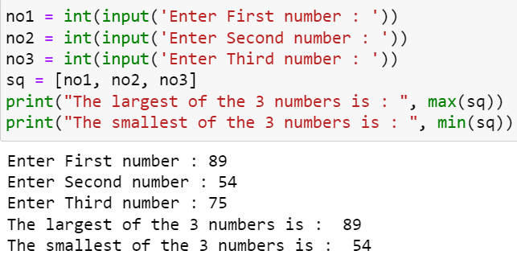Read 3 numbers and find the largest and smallest



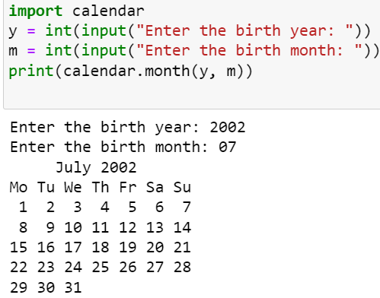**Use modules/packages**

1. Print the month calendar depending on your DOB



1. Find the number of digits in the factorial of a given number

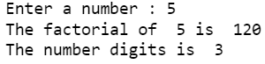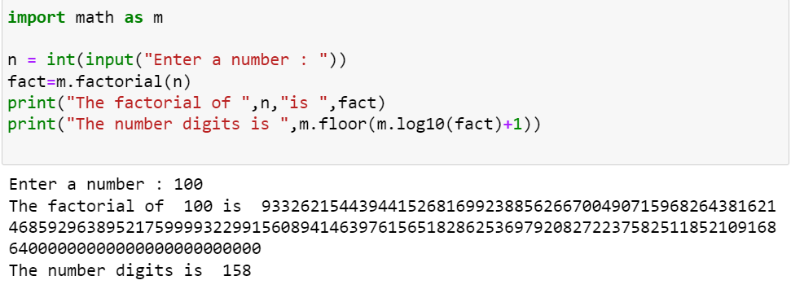

1. Find the sqrt of first and last digit of a number

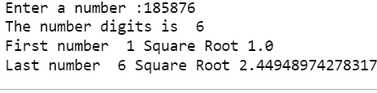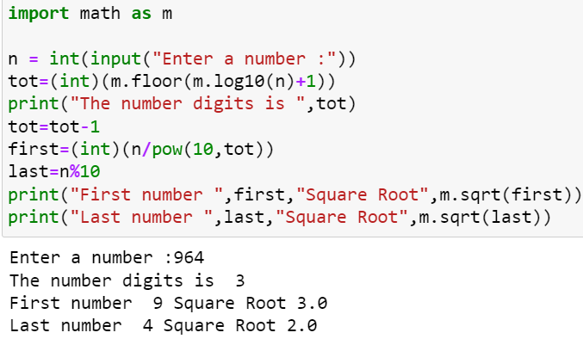

**Using if**

1. Check whether the given year is leap year or not.

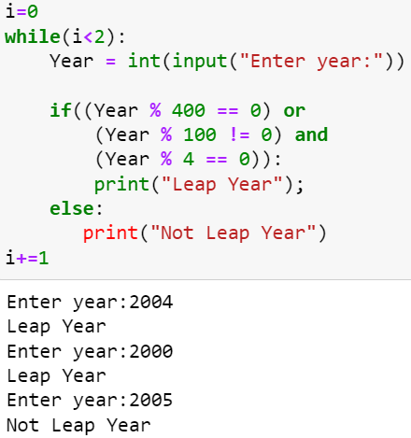

1. Write a python program to read a number and recursively add the digits in it

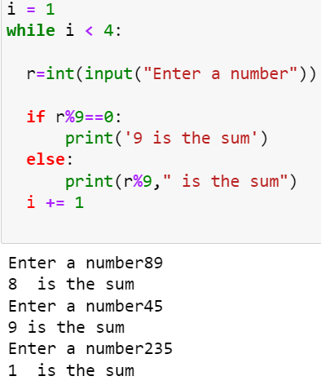

1. 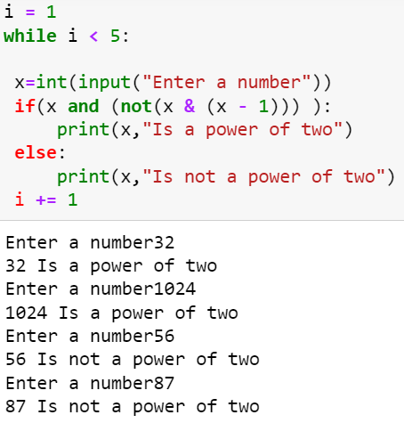Check whether the given number is power of 2



1. Write a program to check the quadrant of a given point(x,y)**( University question)**

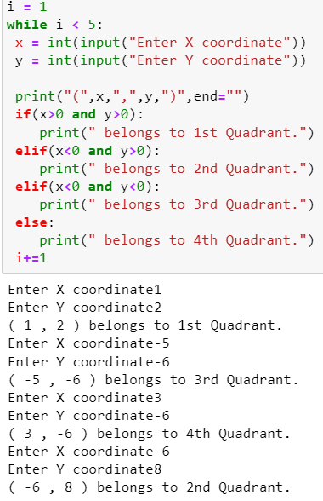

1. Write a program to get the absolute value of a number without using the abs() function**.(university question)**

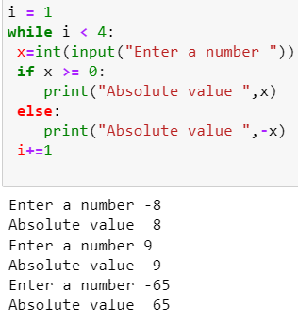

1. Find the roots of a quadratic equation

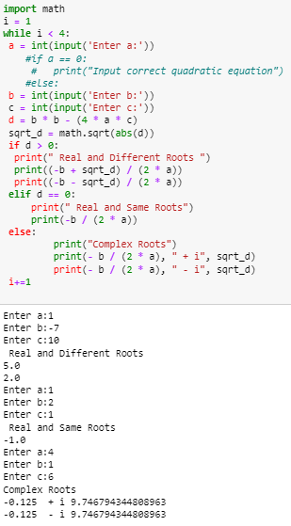

1. Write a program that accepts the length of three sides of a triangle as input and determine whether or not the triangle is a right triangle**.( university question)**

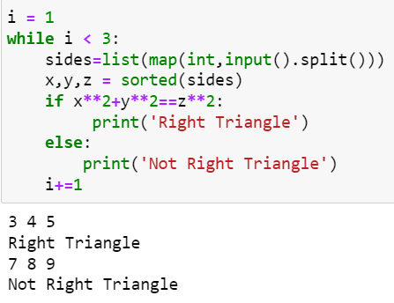

**Using while/for**

1. Generate the Fibonacci series 0 1 1 2 3 5 8…..n ( use while..read n)

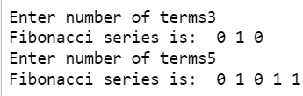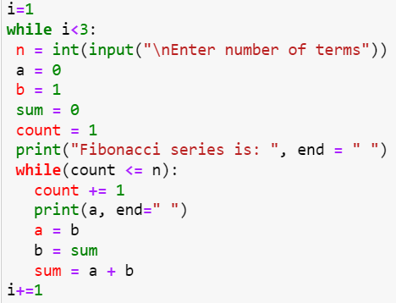

1. Reverse a Number ( i/p: 123 o/P 321)

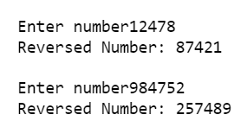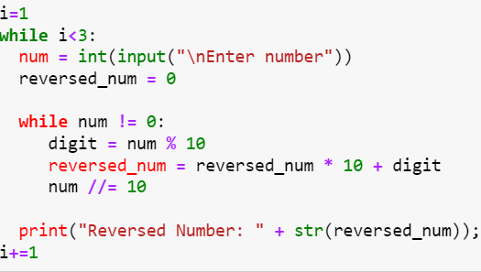

1. Check whether the given 3 digit number is **Armstrong Number**. Eg:153 ( 1+125+27=153) sum of cubes of digits=number.

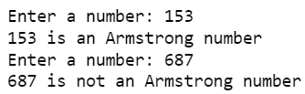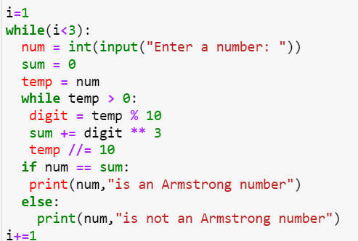

1. Check whether the given number is a **Krishnamurthy number**

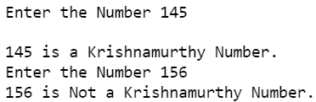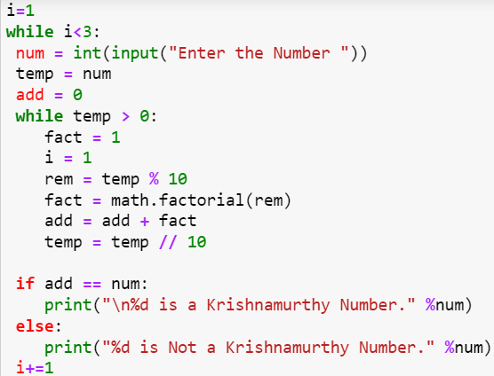

1. Check whether the given number is **Prime or not**

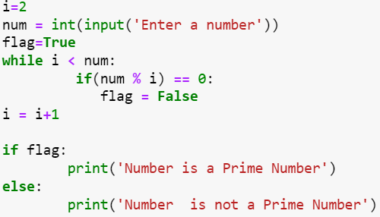

**Nested Loops(for/while**)

1. Print all prime numbers less than 100.

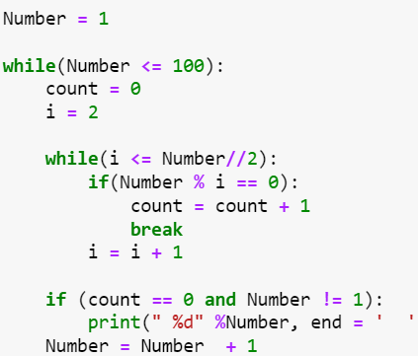

1. Print the binary equivalent of each digit of the given number.

